Lab 1: Write a program to simulate coin toss game using Monte Carlo Simulation Technique
Program
#include<stdio.h>
#include<stdlib.h>
#include<time.h>
int main()
{
int head=0,tail=0,itr;
double r;
srand(time(NULL));
printf("Enter number of iterations\n");
scanf("%d",&itr);
for(int i=1;i<=itr;i++)
{
r =(double) rand()/RAND_MAX;
if(r<=0.5)
head++;
else
tail++;
}
printf("Head= %d\n",head);
printf("Tail = %d\n",tail);
if(head>tail)
printf("Head wins by %d",head-tail);
else
printf("Tail wins by %d",tail-head);
}

Lab 2 Write a C program to find out value of PI using Monte Carlo Simulation Technique
Program
#include <stdlib.h>
#include <stdio.h>
#include <math.h>
#include <string.h>
#define SEED 35791246
int main()
{
int itr=0;
double x,y;
int i,count=0;
double z;
double pi;
printf("Enter the number of iterations used to estimate pi: ");
scanf("%d",&itr);
srand(SEED);
count=0;
for ( i=0; i<itr; i++)
{
x = (double)rand()/RAND_MAX;
y = (double)rand()/RAND_MAX;
z = x*x+y*y;
if (z<=1.0)
count++;
}
pi=(double)count/itr*4;
printf("Value of PI = %f",pi);
return 0;
}

Lab 3: Write a C program to find area between given interval of a function using Monte Carlo Simulation method
Program:
#include <stdio.h>
#include <stdlib.h>
#include <time.h>
#define F(x) (x*x)
#define xl 1
#define yl 1
#define xu 2
#define yu 4
#define N 10000
int main()
{
int xran,yran,n=0,a=1,b=2,c=4,i;
float area;
srand(time(0));
for(i=1;i<=N;i++)
{
xran = (rand() % (xu - xl + 1)) + xl;
yran = (rand() % (yu - yl + 1)) + yl;
if(xran*xran<=yran)
n++;
}
printf("Number of points = %d\n",n);
area = c*(b-a)*(float)n/N;
printf("The area = %f",area);
return 0;
}

Lab 4: Write a C program to generate 10 random numbers using Linear Congruential method
Program:
#include<stdio.h>
#include<stdlib.h>
int main()
{
int x0,x,a,c,M=101;
x0 = 31,a=17,c=13;
double r;
for(int i=1;i<=15;i++)
{
x = (a*x0+c)%M;
r = (double)x/M;
printf("%f\n",r);
x0 = x;
}
}

Lab 5: Write a C program to generate 10 random numbers using mid square method
Program:
#include<stdio.h>
#include<stdlib.h>
#include<math.h>
#include<conio.h>
int main()
{
long int i,s,x,y,z,nd,seed;
int n;
seed=61;
printf("How many random numbers to be generated\n");
scanf("%d",&n);
for(i=1;i<=n;i++)
{
s = (seed*seed);
y = s/10.0;
z = y/100.;
x = int((y/100.-z)*100.);
printf("x = %d\n",x);
seed = x;
printf(" %4ld ",x);
}

}

Lab 6: Write a C program to that tests random numbers for frequency using Kolmogorov S test
Program:
#include<conio.h>
#include<stdio.h>
#define N 5
#define Dalpha 0.665
int main()
{
float R[N] = {0.05,0.14,0.44,0.81,0.93};
float X[N],Y[N],Z[N];
float D1,D2,D;
int i;
for(i=1;i<=N;i++)
{
X[i-1] = (double)i/N;
}
for(i=1;i<=N;i++)
{
Y[i-1] = (double)i/N-R[i-1];
}
for(i=1;i<=N;i++)
{
Z[i-1] = R[i-1]-(double)(i-1)/N;
}
D1 = Y[0];
for(i=1;i<N;i++)
{
if(D1<Y[i])
D1 = Y[i];
}
D2 = Z[0];
for(i=1;i<N;i++)
{
if(D1<Z[i])
D1 = Z[i];
}
D = (D1>D2)?D1:D2;
printf("D = %0.2f",D);
if(D<Dalpha)
printf("Random numbers are uniformally distributed\n");
else
printf("Random numbers are not uniformally distributed\n");

}

Lab 7: Write a C program that tests random numbers for frequency using chi-Square test
Program:
#include<stdio.h>
#include<conio.h>
#define N 100
#define alpha 16.9
void sort(float arr[]);
int main()
{
int i,j;
float XO[10];
float XE[10];
float XOE[10];
float XOE2[10];
float R[10];
float s=0.0;
float x[] = { 0.34,0.83,0.96,0.47,0.79,0.37,0.99,0.37,0.72,0.06,0.18,0.90,
0.76,0.99,0.30,0.71,0.17,0.51,0.43,0.39,0.26,0.25,0.79,
0.77,0.17,0.23,0.99,0.54,0.56,0.84,0.97,0.89,0.64,0.67,
0.82,0.19,0.46,0.01,0.97,0.24,0.88,0.87,0.70,0.56,0.56,
0.82,0.05,0.81,0.30,0.40,0.64,0.44,0.81,0.41,0.05,0.93,
0.66,0.028,0.94,0.64,0.47,0.12,0.94,0.52,0.45,0.65,0.10,
0.69,0.96,0.40,0.60,0.21,0.74,0.73,0.31,0.37,0.42,0.34,
0.58,0.19,0.11,0.46,0.22,0.99,0.78,0.39,0.18,0.75,0.73,0.79,
0.29,0.67,0.74,0.02,0.05,0.42,0.49,0.49,0.05,0.62,0.78 };
sort(x);
for(i=0;i<10;i++)
{
XO[i]=0.0;
XE[i]=10.0;
}
for(i=0;i<N;i++)
{
if(x[i]<=0.1)
XO[0]++;
else if(x[i]<=0.2)
XO[1]++;
else if(x[i]<=0.3)
XO[2]++;
else if(x[i]<=0.4)
XO[3]++;
else if(x[i]<=0.5)
XO[4]++;
else if(x[i]<=0.6)
XO[5]++;
else if(x[i]<=0.7)
XO[6]++;
else if(x[i]<=0.8)
XO[7]++;
else if(x[i]<=0.9)
XO[8]++;
else if(x[i]<=1.0)
XO[9]++;
}

for(i=0;i<10;i++)
{
XOE[i] = XO[i]-XE[i];
XOE2[i] = XOE[i]*XOE[i];
R[i] = XOE2[i]/XE[i];
s = s+R[i];
}
printf("s = %0.2f\n",s);
printf("Alpha at 5%% level of significance for n=9 is %0.2f\n",alpha);
if(s<=alpha)
printf("Accepted");
else
printf("Rejected");

}
void sort(float x[])
{

int i,j;
float temp;
for(i=0;i<N;i++)
{
for(j=0;j<N-1;j++)
{
if(x[j+1]<x[j])
{
temp = x[j];
x[j] = x[j+1];
x[j+1] = temp;
}
}
}
}

Lab 8: Write a program to test random numbers for independence using autocorrelation method
Programs:
#define N 30
#include<stdio.h>
#include<math.h>
int main()
{
int i,m,M,k;
i=2,m=5;
M = ((N-i)/m)-1;
float s35=0,r35,z0;
float R[] = {0.12,0.01,0.23,0.28,0.89,0.31,0.64,0.28,0.83,0.93,0.99,
0.15,0.33,0.35,0.91,0.41,0.60,0.27,0.75,0.88,0.68,0.49,0.05,0.43,0.95,
0.58,0.19,0.36,0.69,0.87};
for(k=0;k<=M;k++)
{
s35 =s35+R[i+k*m]*R[i+(k+1)*m];
}
s35 = s35/(M+1);
s35 = s35-0.25;
r35 = sqrt(13*M+7)/(12*(M+1));

z0 = r35/s35;
if(z0<=1.96)
printf("The null hypothesis that numbers are independent is accepted\n");
else

printf("The null hypothesis that numbers are independent is not accepted\n");
return 0;
}

Lab 9: Write a program to test whether the given matrix is Markov or not
Program
#include<stdio.h>
#define N 3
#define M 3
int isMarkovMatrix(float m[][N])
{
int i,j,s,t=1;
for(i=0;i<M;i++)
{
s=0;
for(j=0;j<N;j++)
{
s = s+m[i][j];
}
if(s>1)
{
t=0;
break;
}
}
return t;
}
void read(float m[][N])
{
printf("Enter element of %d*%d matrix\n",M,N);
for(int i=0;i<M;i++)
{
for(int j=0;j<N;j++)
{
scanf("%f",&m[i][j]);
}
}
}
int main()
{
float matrix[M][N];
read(matrix);
if(isMarkovMatrix(matrix))
printf("The matrix is Markov Matrix\n");
else
printf("The matrix is not Markov matrix\n");
return 0;
}

Lab 10: Write a program to simulate the game called DiceToss.
Program:
#include<stdio.h>
#include<conio.h>
#include<stdlib.h>
#include<time.h>
int Arand()
{
int r;
r = 1+rand()%5;
return r;
}
int Brand()
{
int r;
r = 1+rand()%5;
return r;
}
int main()
{
srand(time(0));
int sa=0,sb,a,b,x,y;
a = Arand();
b = Arand();
sa = a+b;
x = Brand();
y = Brand();
sb = x+y;
if(sa>sb)
printf("A wins the game by %d points\n",sa);
else
printf("B wins the game by %d points\n",sb);
return 0;
}

Program 11: Write C program to simulate single server queuing system
Program:
#include<stdio.h>
#include<conio.h>
#include<math.h>
#include<stdlib.h>
int main()
{
int kk,i,j,run=10;
float x,iat,st, awt, pcu,wt=0,it=0;
float mean=10.0, sd= 1.5, mue=9.5, sigma=1.0;
float sb = 0.0,se=0.0,cit=0, cat=0, cwt=0;
printf("\nIAT CAT SB ST SE CWT CIT");

for(j=1;j<=run;++j)
{
float sum=0;
for(i=1;i<=12;++i)
{
x = rand()/32768.0;
sum = sum+x;
}
iat = mean+sd*(sum-6.0);
cat = cat+iat;
if(cat<=se)
{
sb = se;
wt = se-cat;
cwt = cwt+wt;
}
else
{
sb = cat;
it = sb-se;
cit = cit+it;
}
sum = 0;
for(i=1;i<=12;++i)
{
x = rand()/32768.0;
sum = sum+x;
}
st = mue+sigma*(sum-6.0);
se = sb+st;
printf("\n %5.2f %6.2f %6.2f %6.2f %6.2f %6.2f %6.2f",iat,cat,sb,st, se, cwt,cit);
}
awt = cwt/run;
pcu = ((cat-cit)*100.0)/cat;
printf("\n Average waiting time = %6.2f",awt);
printf("\nPercentage capacity untilization = %6.2f",pcu);

}

Lab 12 : Write a GPSS to simulate following problem
A machine tool in a manufacturing shop is turning out parts at the rate of one every 5 minutes. As they are finished, the parts go to an inspector, who take 4+-3 minutes to examine each one and rejects about 10 % of the parts. Each part will be represented by one transaction and the time unit selected for the problem will be 1 minute

Program:
GENERATE 5
ADVANCE 4,3
TRANSFER 0.1, ACC,REJ
ACC TERMINATE 1
REJ TERMINATE 1
START 1000

Lab 13: Write a program in GPSS to simulate barber shop problem
Program:
GENERATE 18,6
ADVANCE 1
QUEUE SEAT
SEIZE JOE
DEPART SEAT
ADVANCE 15,3
RELEASE JOE
TERMINATE 0

GENERATE 540
TERMINATE 1

START 1

Four Year Board question solved: (include this for practical lab_ by correcting if required)
Lab-14
2080
A machine tool in a manufacturing shop is turning out parts at the rate off one every 5 minutes. As they are finished the parts go on an inspector who takes 10 ± 3 minutes to examine each one and rejects 10% of the parts. Represent the system in GPSS using the concept of facility and run the simulation for 500 parts.

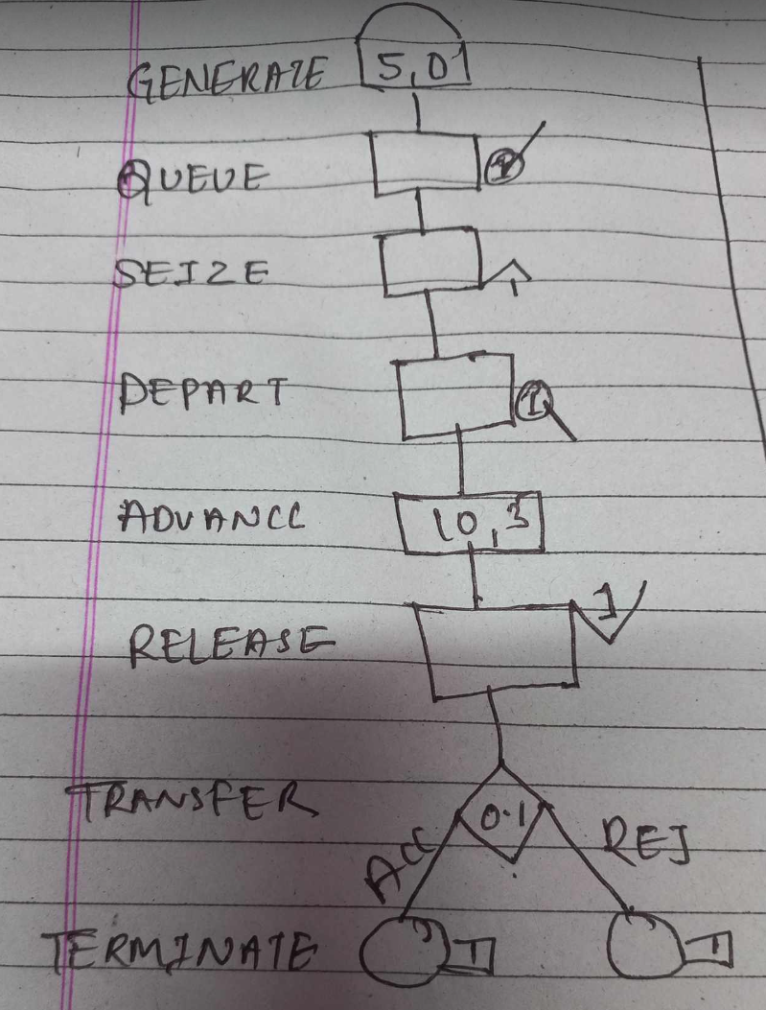

Code:
GENERATE 5,0
QUEUE 1
SEIZE 1
DEPART 1
ADVANCE 10,3
RELEASE 1
TRANSFER 0.1,ACC,REJ
ACC TERMINATE 1
REJ TERMINATE 1
START 500

Lab-15
2079
Customers arrive at Joey Barbershop one every 15±3 minutes and it takes Joey 18±2 minutes to cut hair of a customer. Create a GPSS model with block diagram for the Barbershop using the concept of facility and run the simulation for 9 hours.

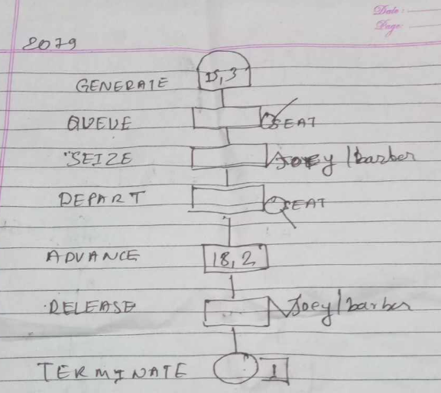

CODE:
GENERATE 15,3
QUEUE SEAT
SEIZE JOY
DEPART SEAT
ADVANCE 18,2
RELEASE JOY
TERMINATE 0
TIME GENERATE 540
TERMINATE 1
START 1

Lab-16
2078
Workers come to a supply store at the rate of one every 6(+-) 2minute. Their requisitions are processed by one of the two clerks who take 8 (+-) 2 minutes for each requisition. The requisitions are then passed to a single storekeeper who fills them one at a time, taking 6(+-)3 minutes for each. Draw GPSS Block diagram to simulate The above problem for 100 requisitions.

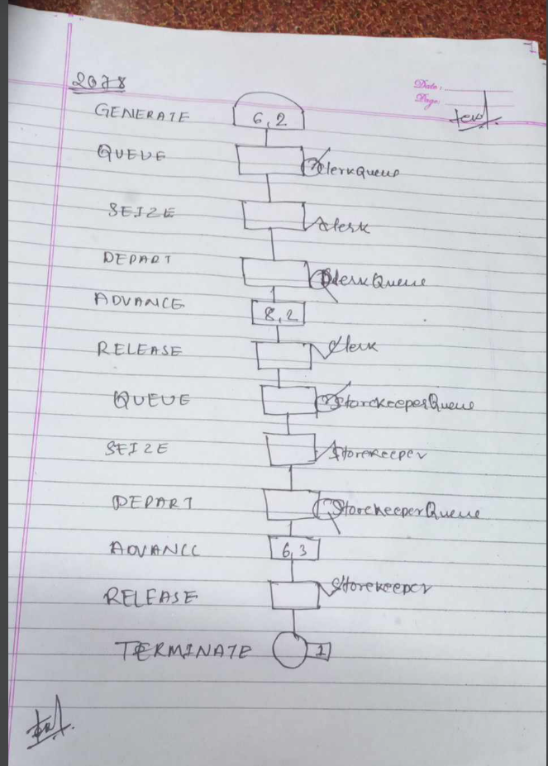

CODE:
GENERATE 6,2
QUEUE ClerkQueue
SEIZE Clerk
DEPART ClerkQueue
ADVANCE 8,2
RELEASE Clerk
QUEUE StorekeeperQueue
SEIZE Storekeeper
DEPART StorekeeperQueue
ADVANCE 6,3
RELEASE Storekeeper
TERMINATE 1
START 100

Lab 17

2076
Parts are being made at the rate of one every 10 minutes. They are of two types, A and B. And are mixed randomly with about 10% being type B. A separate inspector is assigned to examine each part. Inspection of part A takes 6 ± 2 minutes. Both inspector rejects 10% of parts they inspect. Draw GPSS block diagram to simulate the above problem for 100 parts.

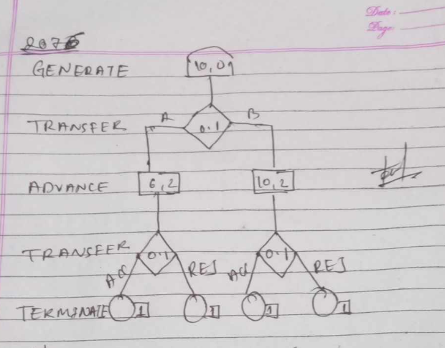

CODE:
GENERATE 10,0
TRANSFER 0.1, A, B

A ADVANCE 6, 2
TRANSFER 0.1, ACC, REJ
ACC TERMINATE 1
REJ TERMINATE 1

B ADVANCE 10, 2
TRANSFER 0.1, ACC2, REJ2
ACC2 TERMINATE 1
REJ2 TERMINATE 1
START 100

Lab-18: A barber shop simulator
We are modeling a barber shop with the following qualities:
- The shop contains one barber and one barber’s chair, open for eight hours in a day.
- Customers arrive on average every 18 minutes, with the arrival time varying between 12 and 24 minutes.
- If the barber is busy, the customer will wait in a queue.
- Once the barber is free, the next customer will have a haircut.
- Each haircut takes between 12 and 18 minutes, with the average being 15 minutes.
- Once the haircut is done, the customer will leave the shop.

We want to answer these questions:
- How utilized is the barber through the day?
- How long does the queue get?
- On average, how long does a customer have to wait.

Solution:
Here we want to find:
- Barber utilization
- Maximum/average queue length
- Average customer waiting time

GPSS program :

GENERATE 18,6
QUEUE 1
SEIZE 1
DEPART 1
ADVANCE 15,3
RELEASE 1
TERMINATE 0

GENERATE 480
TERMINATE 1

START 1

Output:
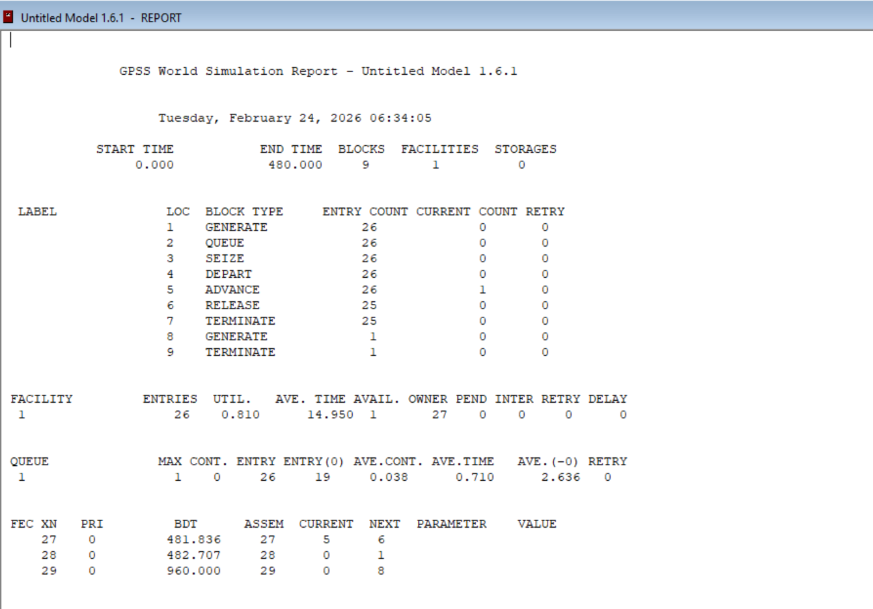

Answer
1. Barber Utilization
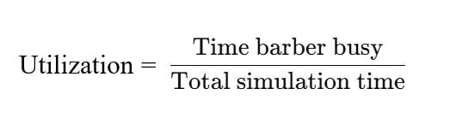
Since:
- Average arrival rate ≈ 1 customer every 18 minutes
- Average service time = 15 minutes

Traffic intensity (ρ):
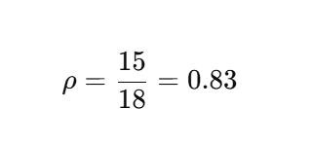
So barber utilization ≈ 83%
Meaning:
Barber is busy about 83% of the day.

2. How Long Does Queue Get?
GPSS report shows:
- Maximum queue length
- Average queue length
Since arrival rate is slightly higher than service rate, small queue will form.
Expected:
- Moderate queue build-up
- But system remains stable because arrival time > service time (18 > 15)

3. Average Waiting Time
GPSS calculates automatically from:
Waiting Time=Time of DEPART−Time of QUEUE entry
Since utilization is high (83%), waiting time will exist but not extremely large.

Lab 19:
A manufacturing shop is turning out parts at rate of one every 5 minutes. As they are finished, the parts go to an inspector, who takes 4±3 minutes to examine each one and rejects about 10% of the parts.
Model 1: Without inspection or wait
GENERATE 5
ADVANCE 4,3
TRANSFER 0.1,REJ,ACC
ACC TERMINATE 1
REJ TERMINATE 1
START 100

Output:
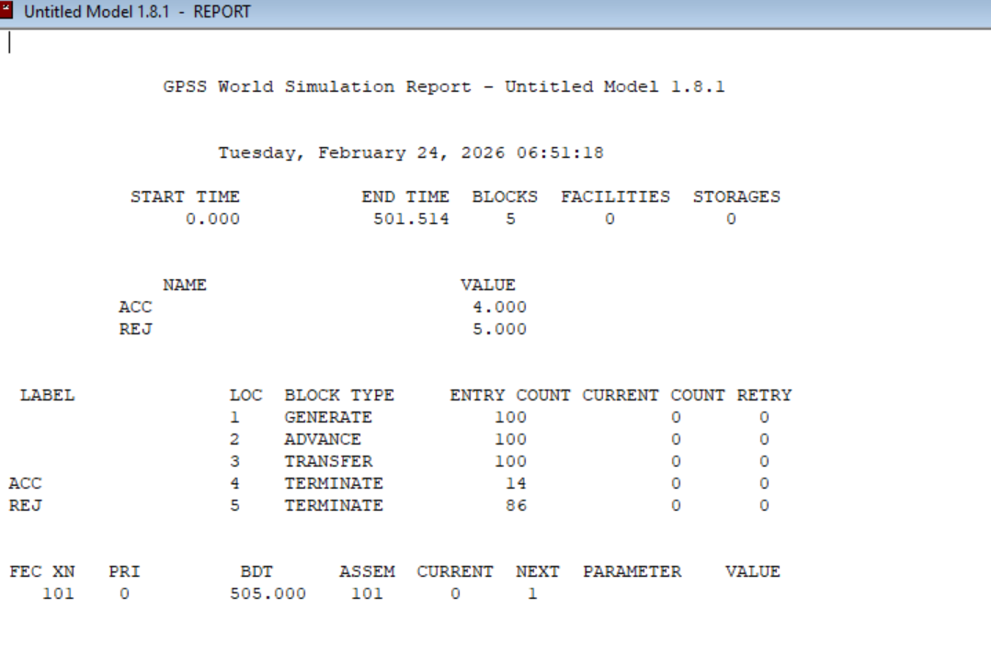

Model 2: Wait/With 1 inspection
* Model With 1 Inspector
GENERATE 5
QUEUE 1
SEIZE 1
DEPART 1
ADVANCE 4,3

TRANSFER 0.1,REJ,ACC

REJ RELEASE 1
TERMINATE 1

ACC RELEASE 1
TERMINATE 1

START 100

Output:
